Chapter 8: Knowledge Management Tools

Practice – Using accessible knowledge in decision making
This is a small demo for students to see the benefits of data management and knowledge retrieval as well as the implementation process.

Case Study
A small supermarket often has to make import decisions for low inventory items. However, the frequent need to track inventory and import goods in batches will consume human resources as well as increase transportation costs. Therefore, it is necessary to have a suitable import plan for a long time. The following process will help the planner have an accurate view of the sales ability to have a suitable plan.
With a dataset of supermarket sales invoices, use Weka software to analyze the data with association rules to see the relationship between products.

Tool
Weka 3: Machine Learning Software in Java
Weka is a collection of machine learning algorithms for data mining tasks. It contains tools for data preparation, classification, regression, clustering, association rules mining, and visualization.

Figure 1: Weka software

Dataset
Data source: https://github.com/2blam/ML/blob/master/apriori/Market_Basket_Optimisation.csv
3 steps to convert data in the correct format of Weka:
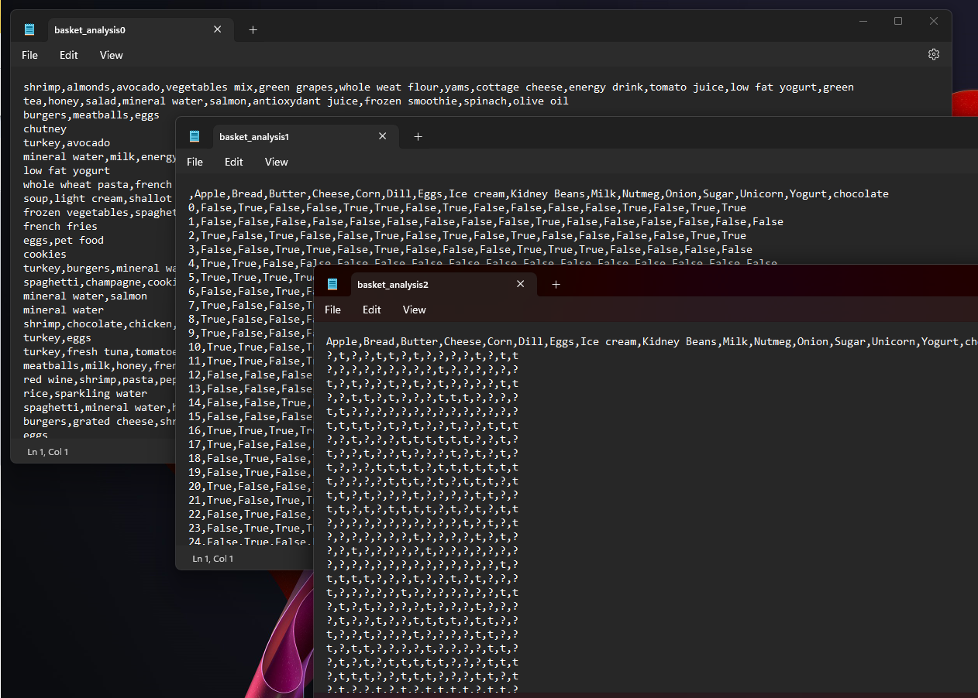
Figure 2: Data form transition levels

Implementation steps
Step1: Open formatted data file
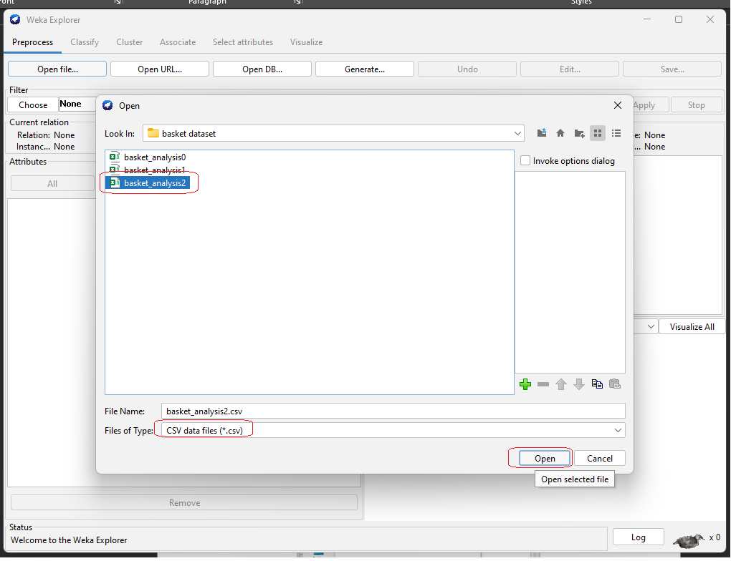
Figure 3: Open formatted data file
Step2: Select the products you want to find a relationship with
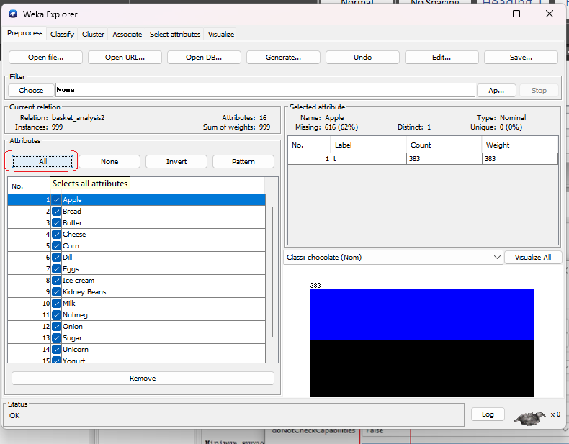
Figure 4: Select the products you want to find a relationship with
Step 3: Define evaluation indicators and start to analysis and get results
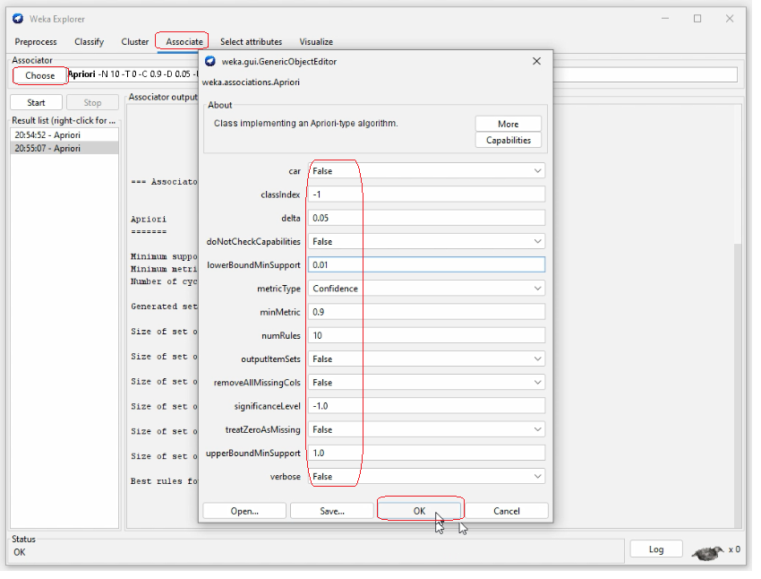
Figure 5: Define evaluation indicators
Step 4: Perform association rule analysis and view the results
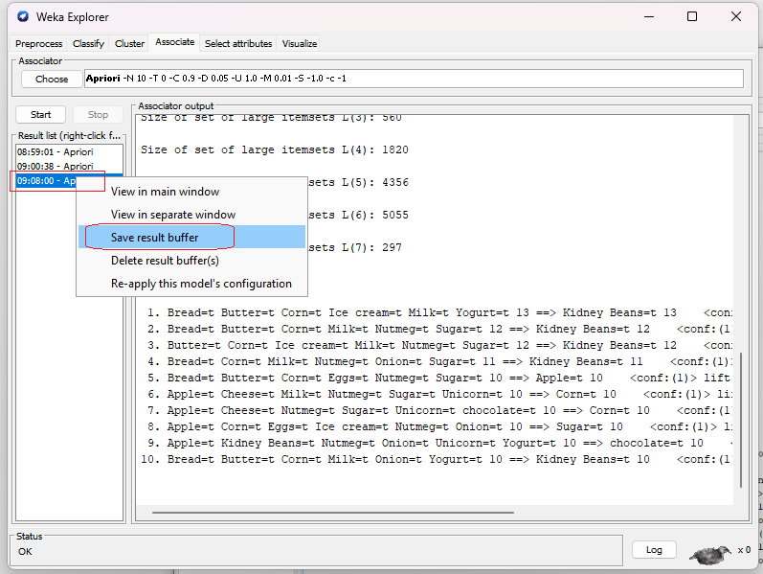
Figure 6: Save result to file
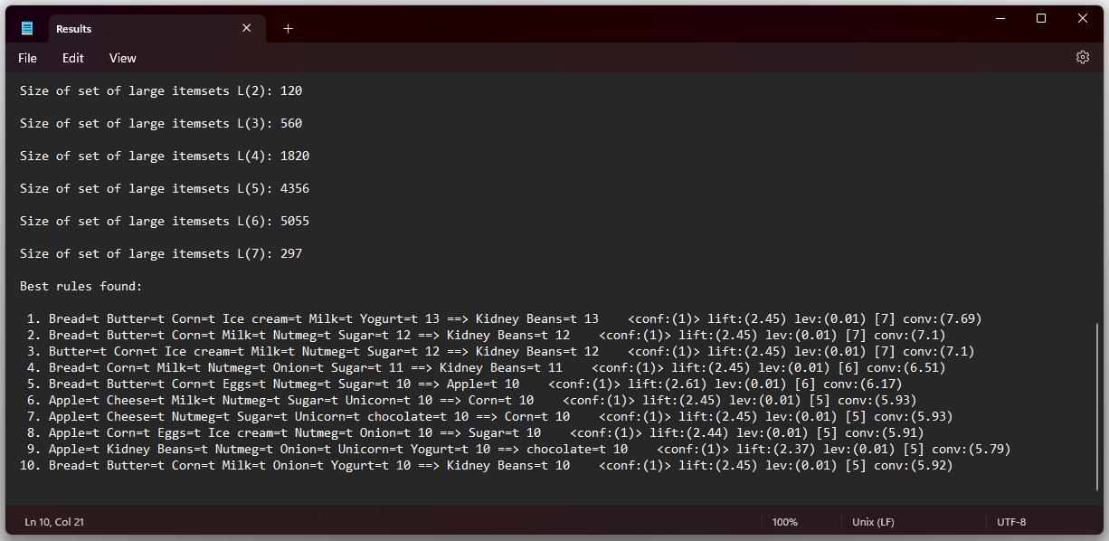
Figure 7: Evaluation results by file association rule

Analysis
1. Bread=t Butter=t Corn=t Ice cream=t Milk=t Yogurt=t 13 ==> Kidney Beans=t 13 <conf:(1)> lift:(2.45) lev:(0.01) [7] conv:(7.69)
Mean: Someone buy Bread, Butter, Corn, Ice cream, Milk, Yogurt, they will buy Kidney Beans
{Bread, Butter, Corn, Ice cream, Milk, Yogurt } -> { Kidney Beans }
2. Bread=t Butter=t Corn=t Milk=t Nutmeg=t Sugar=t 12 ==> Kidney Beans=t 12 <conf:(1)> lift:(2.45) lev:(0.01) [7] conv:(7.1)
{Bread, Butter, Corn, Milk, Nutmeg, Sugar} -> { Kidney Beans }
3. Butter=t Corn=t Ice cream=t Milk=t Nutmeg=t Sugar=t 12 ==> Kidney Beans=t 12 <conf:(1)> lift:(2.45) lev:(0.01) [7] conv:(7.1)
{Butter, Corn, Ice cream, Milk, Nutmeg, Sugar} -> { Kidney Beans }

Conclusion
When planning to import goods, in addition to low-stock items, it is necessary to note that items of the same type, can also be imported and related to each other in the analysis table so that the plan not only solves the problem of out-of-stock. time, but also estimate other appropriate quantities of goods, reducing management and delivery costs.

Do it yourself
Students can do analysis with other topics, dataset source with description is available online at:
- www.kaggle.com
- storm.cis.fordham.edu/~gweiss/data-mining/datasets.html
- waikato.github.io/weka-wiki/datasets/

Case Study
An event company regularly receives contracts to organize outdoor events. However, weather factors can destroy the entire program. So in addition to the experience of the organizer, through the amount of information about the events that have been organized before, planning and implementation will have a higher level of success.
In this exercise, we will use weather information to decide whether to organize an outdoor or indoor activity.

Dataset
Dataset: weather-nominal

